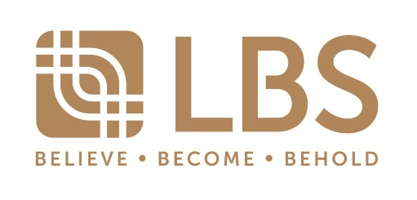

For Immediate Release

LBS BINA HONOURED WITH NUMEROUS AWARDS
AT THE STARPROPERTY AWARDS 2022
Affordability & Digitalization paving new paths for LBS Bina’s successes

Petaling Jaya, 25 August 2022 – The nation’s most prestigious property developers have gathered together at the StarProperty Awards 2022 to laud the achievement in the property development industry. LBS Bina Group celebrates multiple achievements in the real estate industry, a testament that the strategies and diversified portfolio in property developments spearheaded the Group to greater heights and earned the Group the following award:
- All-Stars Award – Performing developer
- The Digital Strategist Award for (Excellent)
- The Business Estate Award (Commercial development) for Cameron Centrum (Honours);
- The Highlander Award for Vines 3, Cameron Golden Hills (Merit);
- The Starter Home Award (Landed) for KITA Mesra Single Storey (Merit);
- The Family Friendly Award (High Rise) for Prestige Residence (Merit);
- The Family Friendly Award (Landed) for KITA Mekar Double Storey (Merit)

Tan Sri Lim Hock San, LBS Executive Chairman said, “LBS is all about curating the ideal homeownership experience, starting from home-viewing all the way to the homebuying phase. Which is why we have been showing steadfast growth in digitalization which not only help homebuyers reach out to our products easier but also help us understand them better. As a result, we have been able to develop well-rounded products that best suit our market. Our vision to house the nation is also made possible thanks to the joint effort of my LBS team and trust given by the nation, which will be the key motivation for us to set higher benchmarks.”
Forged by LBS’ three main pillars, namely Affordability, Connectivity, and Community, among the other winning strategies of LBS Bina’s is focus on digitalization and understand the nation’s dire need for quality homes. The Group have been developing affordable living spaces for more than three decades and this endeavour has been growing progressively. It is a testament that homebuyers value LBS’ community centric developments. Establishing itself as a key performer in the property market, LBS has developments across the Klang Valley, East Coast, Northern and Southern region of Malaysia, LBS has, to date, delivered over 36,000 units. At present, LBS has 16 ongoing projects.
The StarProperty Awards 2022 was helded at the Shangri-La Kuala Lumpur attended by over 520 guests, with Dato' Sri Reezal Merican Bin Naina Merican, the Minister of Housing and Local Government, being the guest of honour and representative to confer the awards to LBS and other winners of the StarProperty Awards 2022.
-End-
About LBS Bina Group Berhad
LBS Bina Group Berhad (“LBS”), an internationally recognized developer with a vision for building and inspiring delightful spaces, is a renowned township developer that has amassed numerous awards through their various developments. By placing people at the heart of their approach, LBS has been building and shaping the nation’s landscape for over 30 years while continuing to meet the market demands for quality and affordable homes.

The continued success of LBS is attributed to the leadership of Executive Chairman, Tan Sri Lim Hock San. In recognition of his leadership, Tan Sri Lim was named as the Property Man of the Year by Malaysia Property Award (formerly known as FIABCI Malaysia Property Awards of Distinction or FIABCI Malaysia Awards of Distinction) in 2018, which is the gold standard for developers in the real estate industry. Further recognition received was the “Oscar Award” in the property fraternity. The award was in recognition of Tan Sri Lim’s perseverance and resilience over time within the industry, excellent demonstration of strong leadership, deep industry knowledge and impeccable values of integrity and responsibility.

To date, LBS with vast land banks spread across Malaysia, will continue to grow in stature and strength, through replicating successful townships such as Bandar Saujana Putra to other parts of Selangor including KITA @ Cybersouth in Dengkil, LBS Alam Perdana in Bandar Puncak Alam and so on. Beyond property development, LBS is also venturing into retail management, hospitality and tourism.

For more information, visit https://lbs.com.my/.

Corporate Communication, Media & Digital, LBS

Email : media@lbs.com.my

